Transportation Research Forum 2013 & International Conference on Advances in Highway Engineering and Transportation Systems
The Transport Research Forum (TRF) 2013 and the International Conference on Advances in Highway Engineering and Transportation Systems (ICAHETS) organized by Transportation Engineering Division of the Department of Civil Engineering, University of Moratuwa was held on 23rd & 24th July 2013 at Mount Lavinia Hotel, Colombo.
Several distinguished academics in the field of transportation and highway engineering presented key note speeches at the conference:
| Prof.H.K.Lam (Hong Kong Polytechnic University) ‘Integration of Road Accident and Hospital Patient Data for Development of Road Casualty Information System in Hong Kong’
| Prof.T.F.Fwa (National University of Singapore) ‘Total Highway Management System’
| Prof.Seungjae Lee (University of Seoul) ‘Public Transport Oriented Policy in Seoul’
| Prof. Chan Wirasinghe (University of Calgary) ‘Ring Rail Transit – An Exploration’
| Prof.Hai Yang (Hong Kong University of Science and Technology) ‘Towards Sustainable Transportation Network Mobility with Tradable Travel Credits’
| Prof. Masao Kuwahara (Tokyo University) ‘Records of Emergency Goods Distribution and Evacuation Behavior at Great East Japan Earthquake on March 11, 2011’

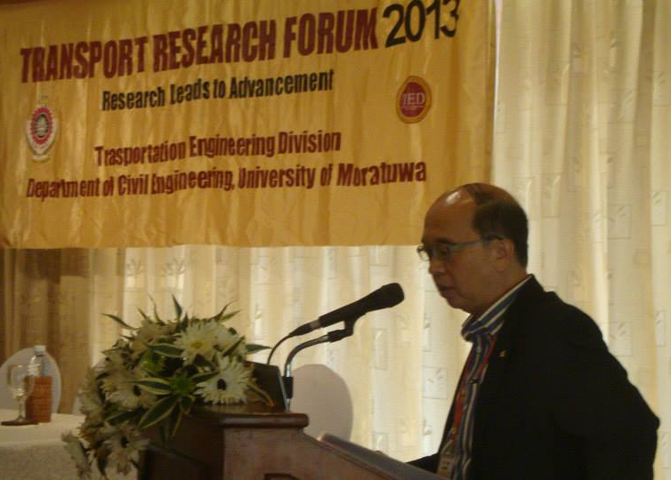
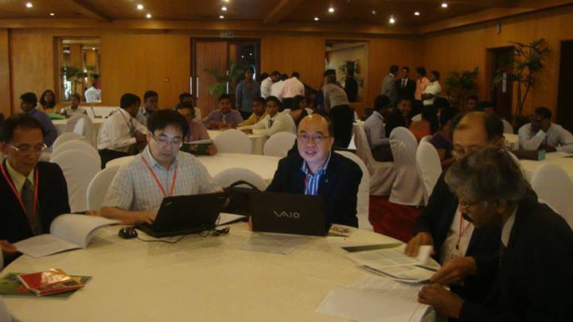
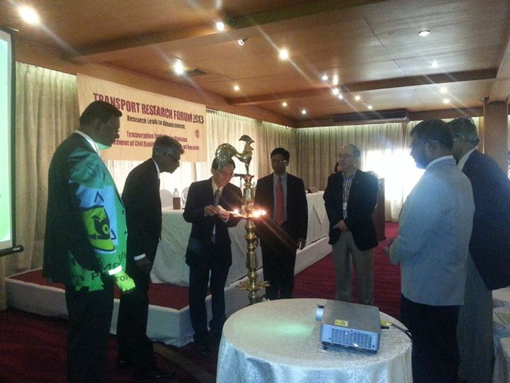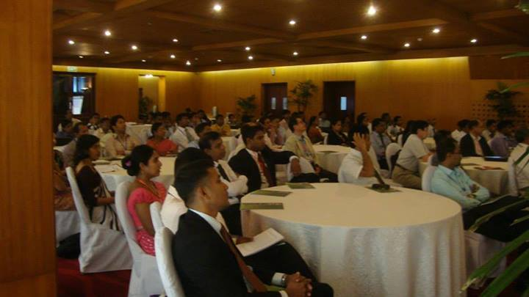

Presentations at ICAHETS
Session 1: Public Transport and Demand Analysis
Public Transport Oriented Policy in Seoul | Seungjae Lee
Ring Rail Transit – An Exploration | S.C. Wirasinghe
cenario Testing with an Integrated Spatial Economic Model for San Diego | Dimantha I. De Silva
Session 2: Transport Planning
Towards Sustainable Transportation Network Mobility with Tradable Travel Credits | Hai Yang
Generating a Population Synthesis for Colombo | Dimantha I. De Silva
Development of Representative Driving Cycle for Colombo- A New Approach | J.M.S.J Bandara
Session 3: Safety and Environment
Records of Emergency Goods Distribution and Evacuation Behavior at Great East Japan Earthquake on March 11, 2011 | Masao Kuwahara
Motorcycle Safety in the United States and Focus Areas for Improvement | Sunanda Dissanayake
Effect of Traffic and Geometric Design Characteristics on Large Truck Crashes | Niranga Amarasingha
Session 4: Pavement Engineering
Steel Fiber Cement Stabilized Aggregate Base for Heavy Traffic | W.K Mampearachchi
Long Term Performance and Durability of HMA Pavements | M.B.S. Fernando
Development of Representative Driving Cycle for Colombo- A New Approach | J.M.S.J Bandara

PRESENTATIONS AT TRF2013
Keynote address
Prof.H.K.Lam (Hong Kong Polytechnic University): “Integration of Road Accident and Hospital Patient Data for Development of Road Casualty Information System in Hong Kong”
Prof.T.F.Fwa (National University of Singapore): ”Total Highway Management System”
Parallel Session H1: Road Safety
Towards a Safer and Effective Bicycle Lane Implementation in Sri Lankan Highways | S.A.S.T Salawavidana
Motorcycle Safety Usage Rates and Motorcycle Injury Severity in Sri Lanka | S. Amarasinghe  Prof Saman Bandara
Parallel Session T1: Demand Analysis and GIS
Use Of GIS as an Integrated Tool, on Selecting Minimum Hazard Traces for New Railways & Highways | K. Wickramarathne  Prof Saman Bandara
A GIS Based Tool to Estimate Transport Demand Associated with Land Use Changes Expected at an Expressway Interchange Township Development | P.C.P. De Silva  M. Aseem  J.M.S.J. Bandara
Automatic Road Extraction form High Resolution Satellite Images | R.M.P.N.S. Bandara  P.C.P. De Silva  J.M.S.J. Bandara
Parallel Session H2: Pavement Engineering
Finding AADT Thresholds for Upgrading Low Volume Roads in Sri Lanka (Using HDM-4 Model) | Y.P.S.R.Piyasena and W.K. Mampearachchi
Analysis of the Flexible Pavement Sections Using Mechanistic - Empirical Method | N.P. Dulwala  W.K Mampearachchi
Evaluation of Temperature Susceptibility Measures in Penetration Grade Bitumen Used in Sri Lanka | J.N.Meegahage  W.K Mampearachchi
Parallel Session T2: Transport Planning and Modeling
Analysis of Factors Affecting Pedestrian Route Choice | C.Hewawasam  J.M.S.J Bandara  S.C. Wirasinghe
Methodology to Identify the Optimum Number of Locations that Minimized Double Counting Errors for Origin – Destination Surveys | P.C.P. De Silva  J.M.S.J Bandara
Study of Bus Crew Behavior and User Complaints | M.P.P.S. Pathirana  J.M.S.J Bandara
Parallel Session H3: Transportation Infrastructure Management
Development of Guidelines to Improve the Infrastructure to Address the Mobility of Blind and Visually Impaired Self Employed People of Sri Lanka | R. A. M. C Ranasinghe  W.K Mampearachchi
Determination of Vehicle Kilometers Travelled and to Find Methodology for Calculating VKT in Future Years | D.A.S.Jayasekera  W.K Mampearachchi
Road Maintenance Management System | P.J.B.Lenadora
Parallel Session T3: Aviation
Fatigue Drivers of Flight Crew Registered In Sri Lanka | AranthiFernando,  Darshi Piyathilake
Passenger Arrival and Waiting Patterns at Terminal Service Centers at Bandaranaike International Airport | D.D.G.A.D.S.Saparamadu  J.M.S.J Bandara
Study of Airport Curbside and Parking Area Operations at Bandaranaike International Airport | S.D.B Galagedera  H.R.Pasindu  J.M.S.J Bandara

